BEST SELLING

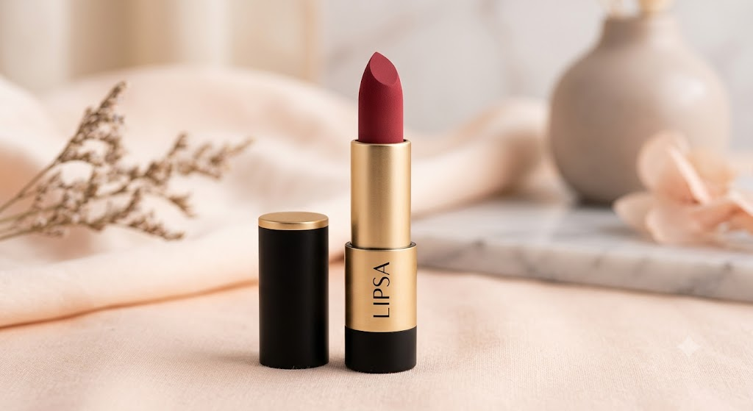
- LIPSA Luxe Matte Lipstick

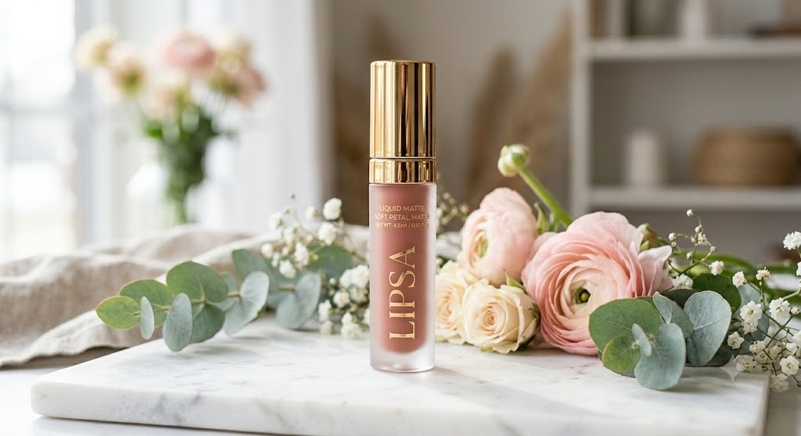
2. LIPSA Velvet Touch Lip Gloss
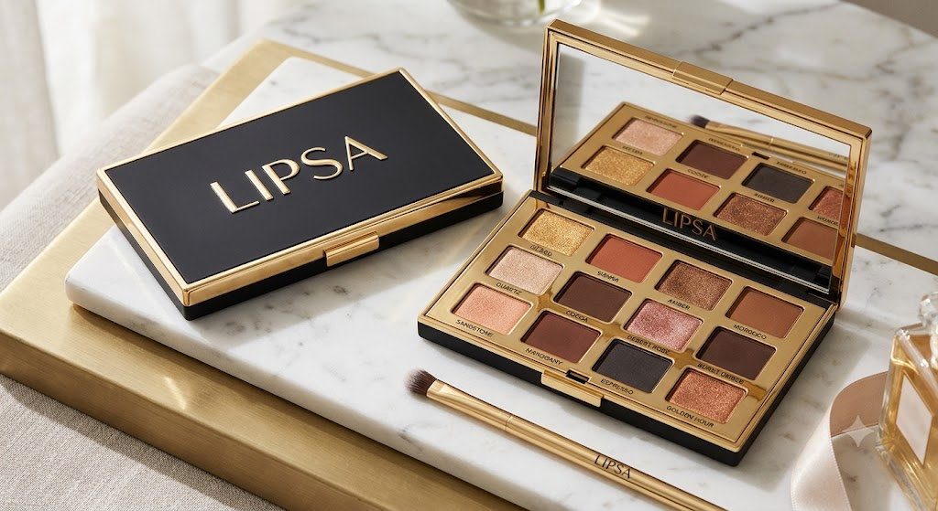
3.LIPSA Royal Eyeshadow Palette

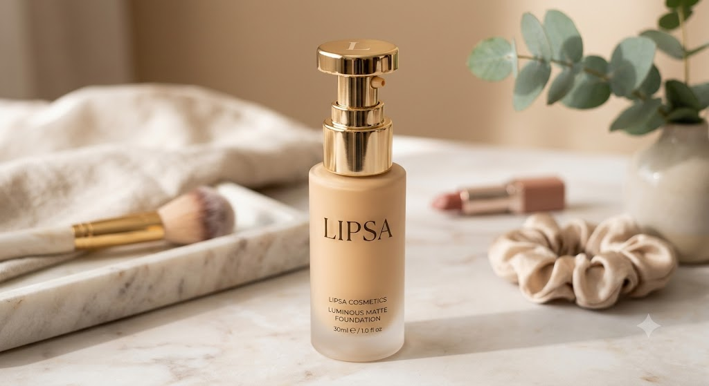
4. LIPSA Radiant Glow Foundation

